Task on CloudFront & Route 53
- Purchase one domain from GoDaddy.
Step 1: Navigate to godaddy website and provide a domain name
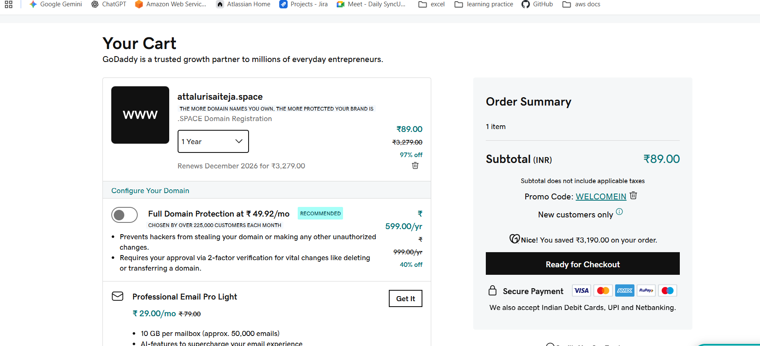
Step 2: Check the deals and confirm the payment
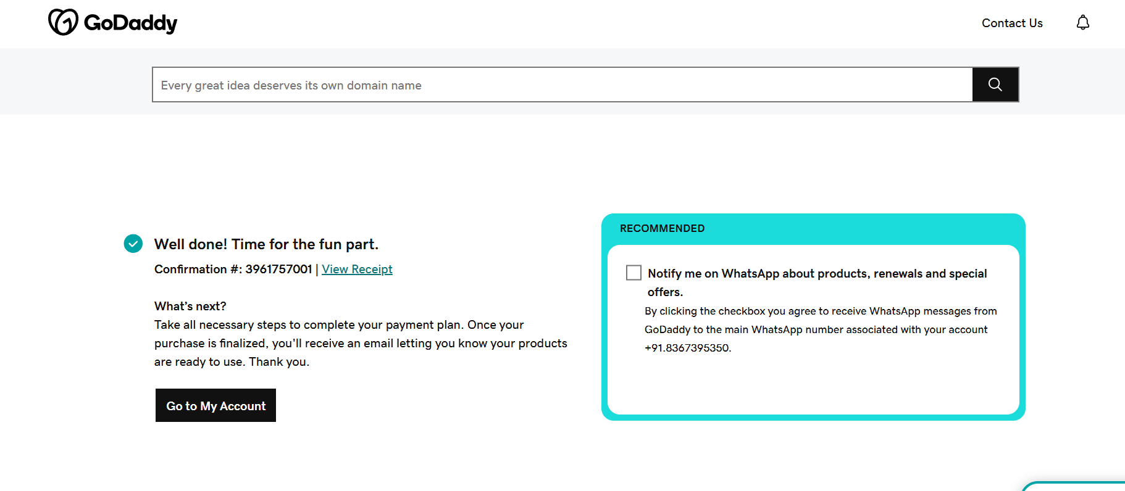
Step 3: Listed the created domain name(attalurisaiteja.space)
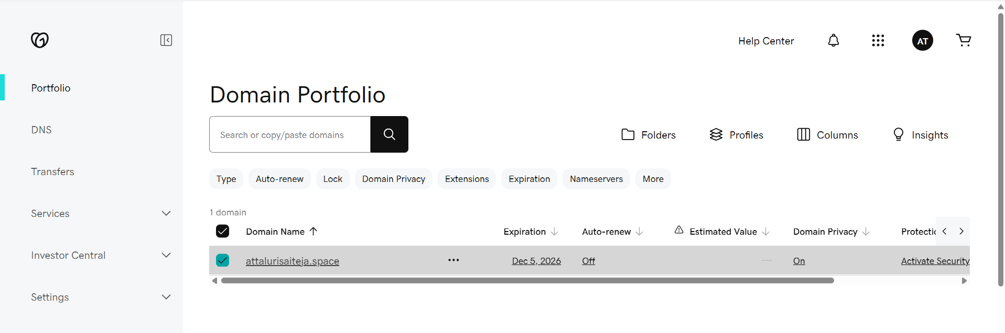
- Deploy static website in S3.
Step 1: create a s3 bucket name same as domain name
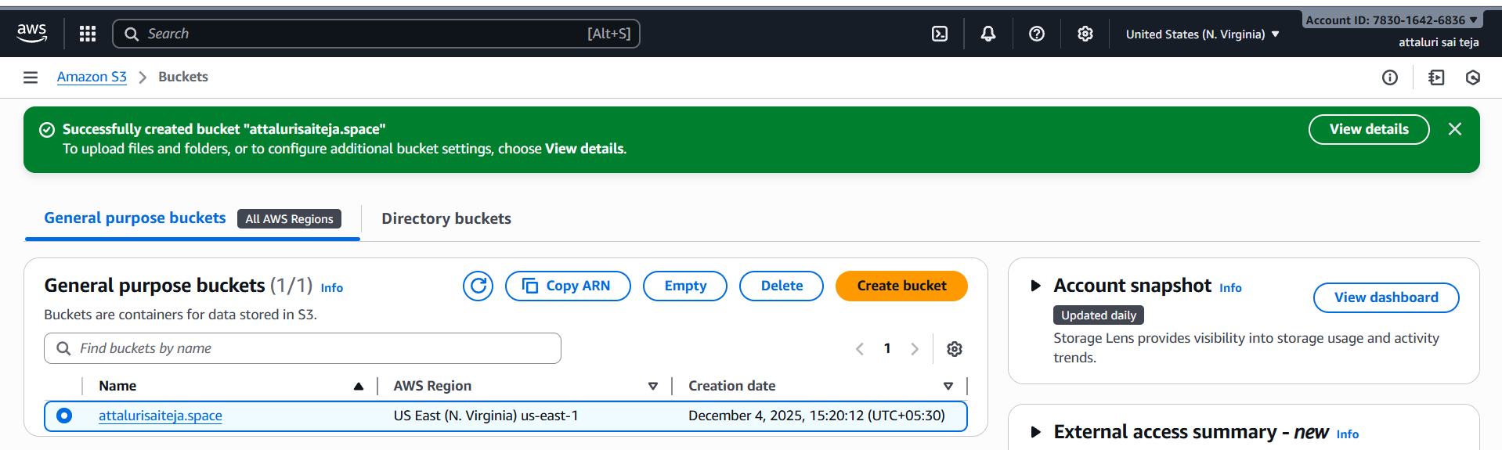
Step 2:Navigate into the bucket and scroll down to get the static website hosting
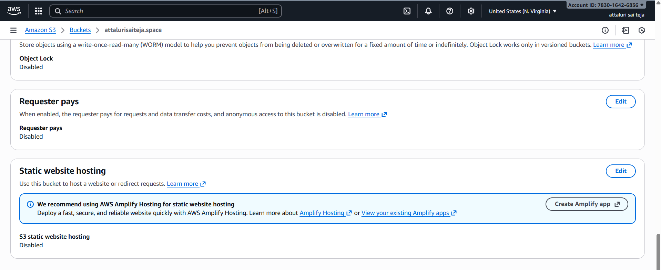
Step 3: Click on edit to setup give the names accordingly
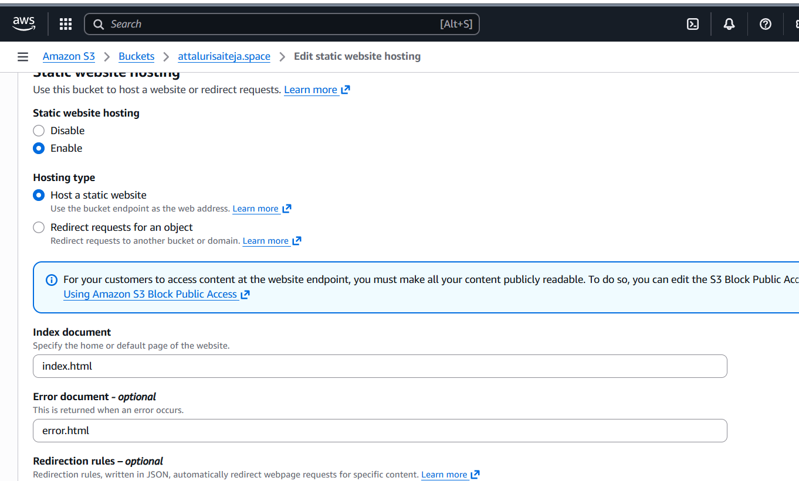
Step 4: Successfully hosted the website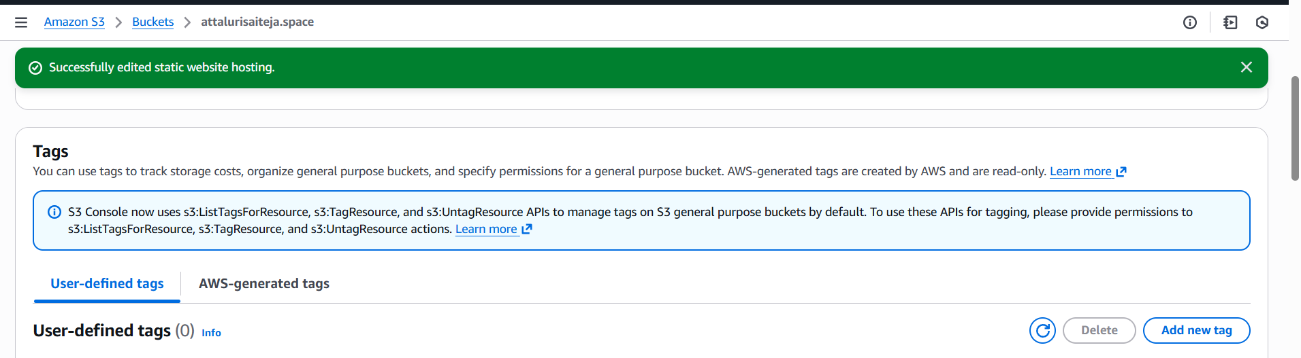
Step 5: Uploading objects in to bucket
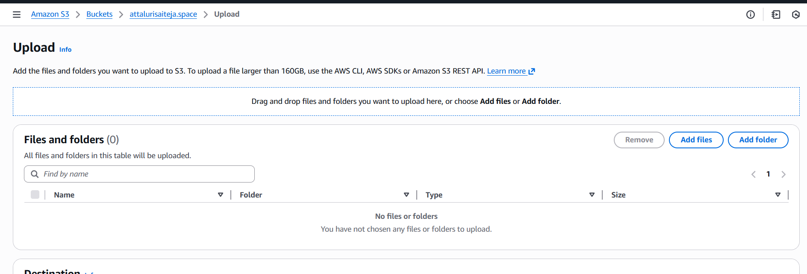
Step 6: Verified the names of objects which I provided while hosting a website
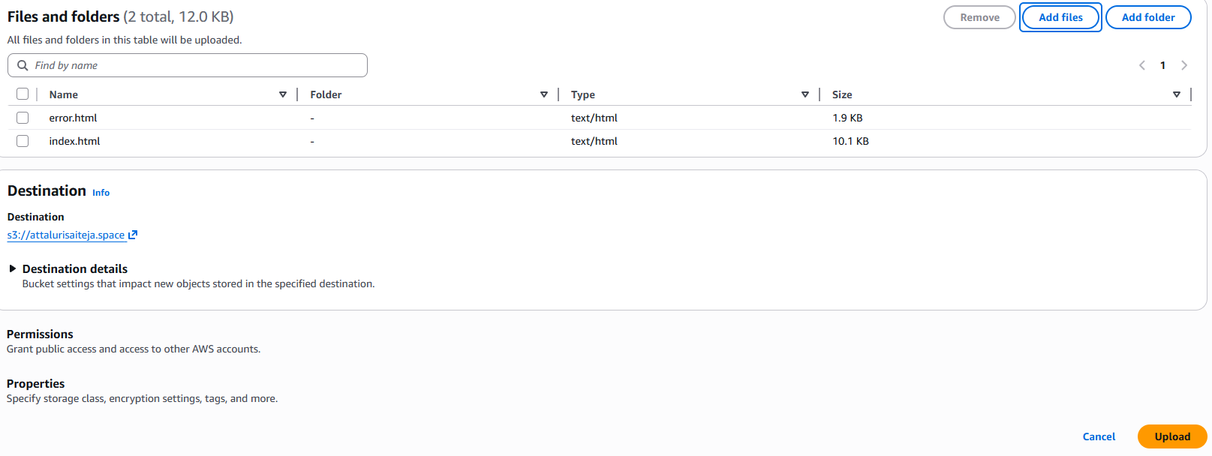

Step 7: Uploaded Successfully
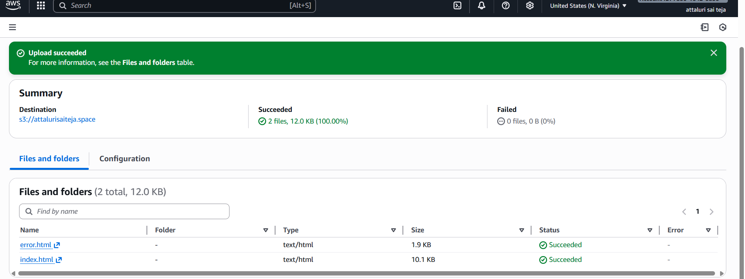
Step 8: With the link tried to open the static website but permission denied so that provide permissions
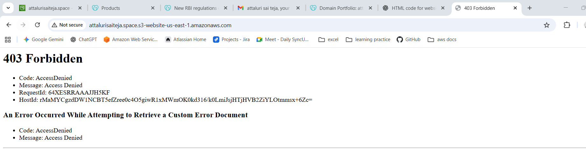
Step 9: Enable the ACL and save the changes
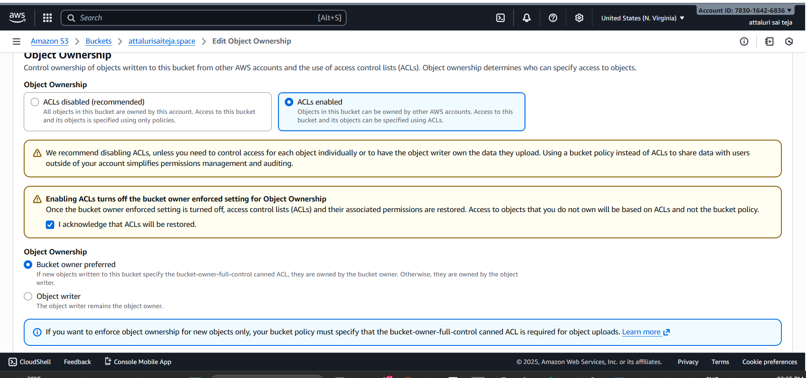

Step 10: Provide only read access to public
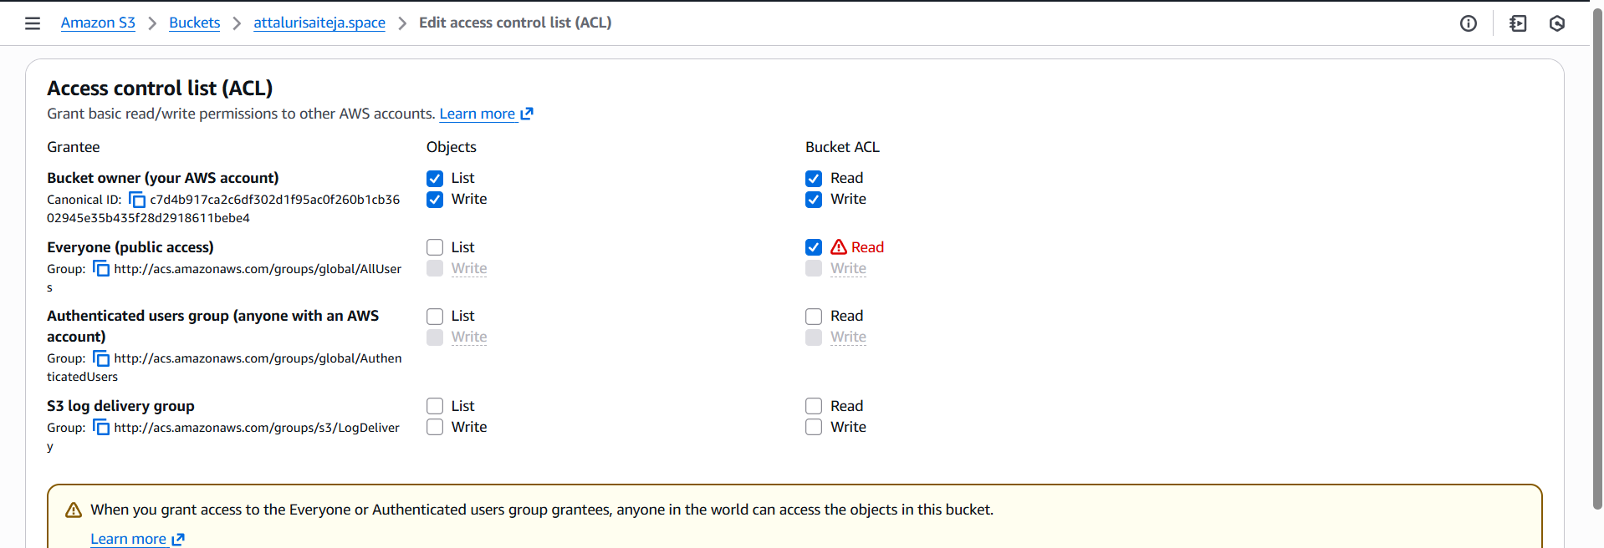
Step 11: Navigate to actions of objects and select make as public for both the objects
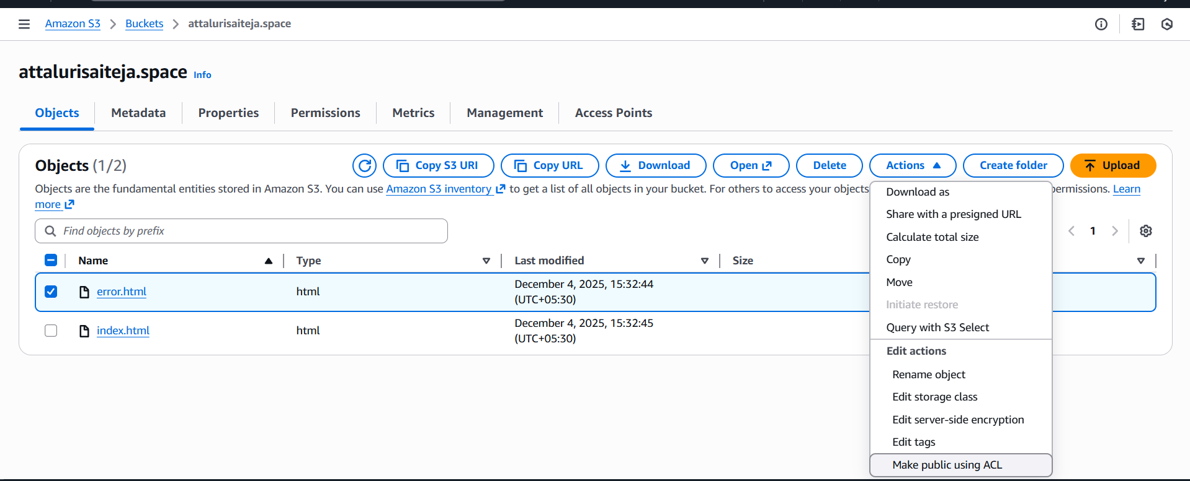
Step 12: Select to make public
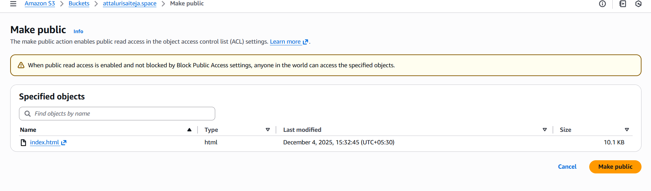

Step 13: Successfully connected to a website
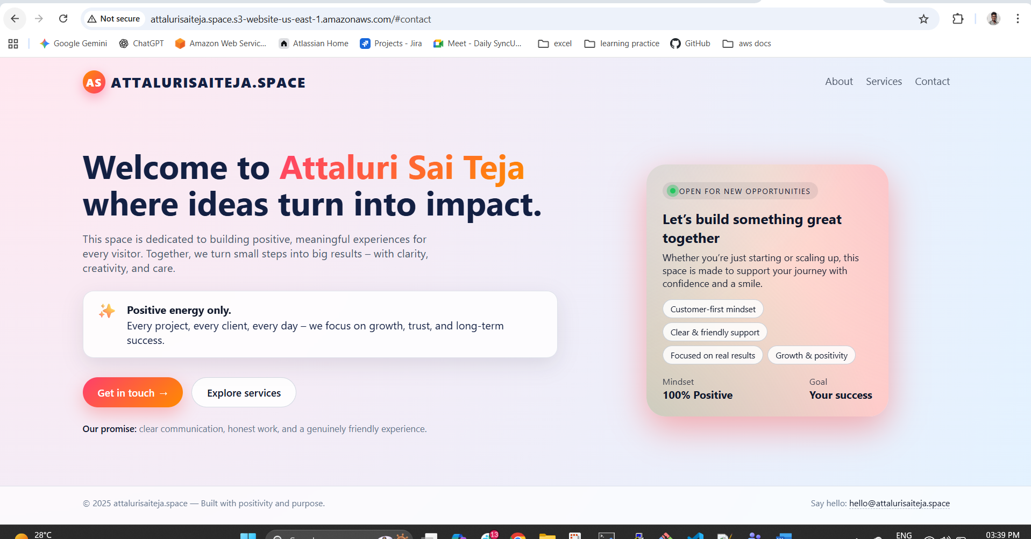
Step 14: deleted the index.html file to get error.html data
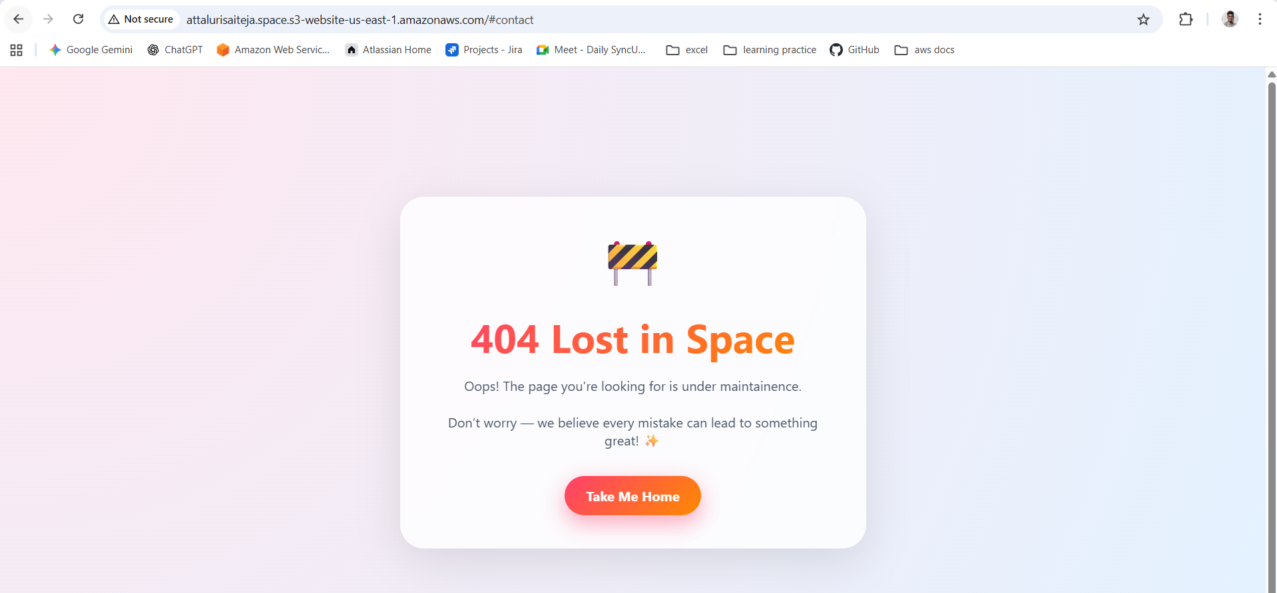

3.Create a CDN and attach one SSL certificate.
Create a Route 53 hosted zone and map the domain with the CDN.
Update the index.html in the S3 bucket and ensure the updated file is accessible using the domain name.
Share the domain name in Slack to test the connectivity

Step1: Navigate top Route 53 and select to create hosted zone
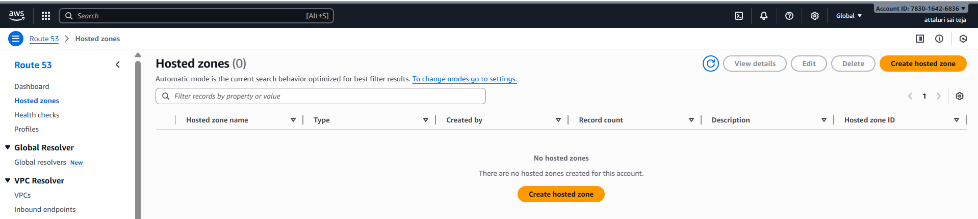
Step 2:Provide the name as domain name and continue
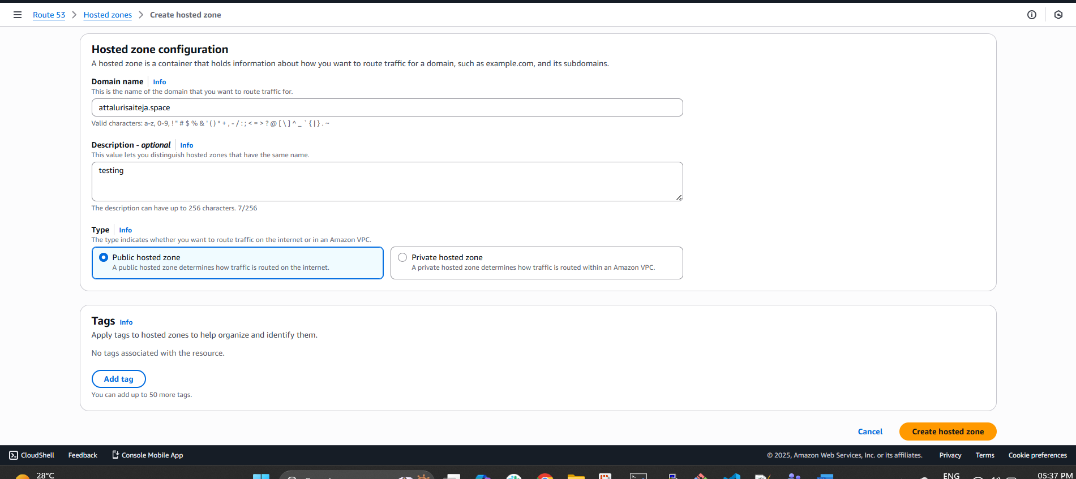

Step 3: Your zone was created successfully
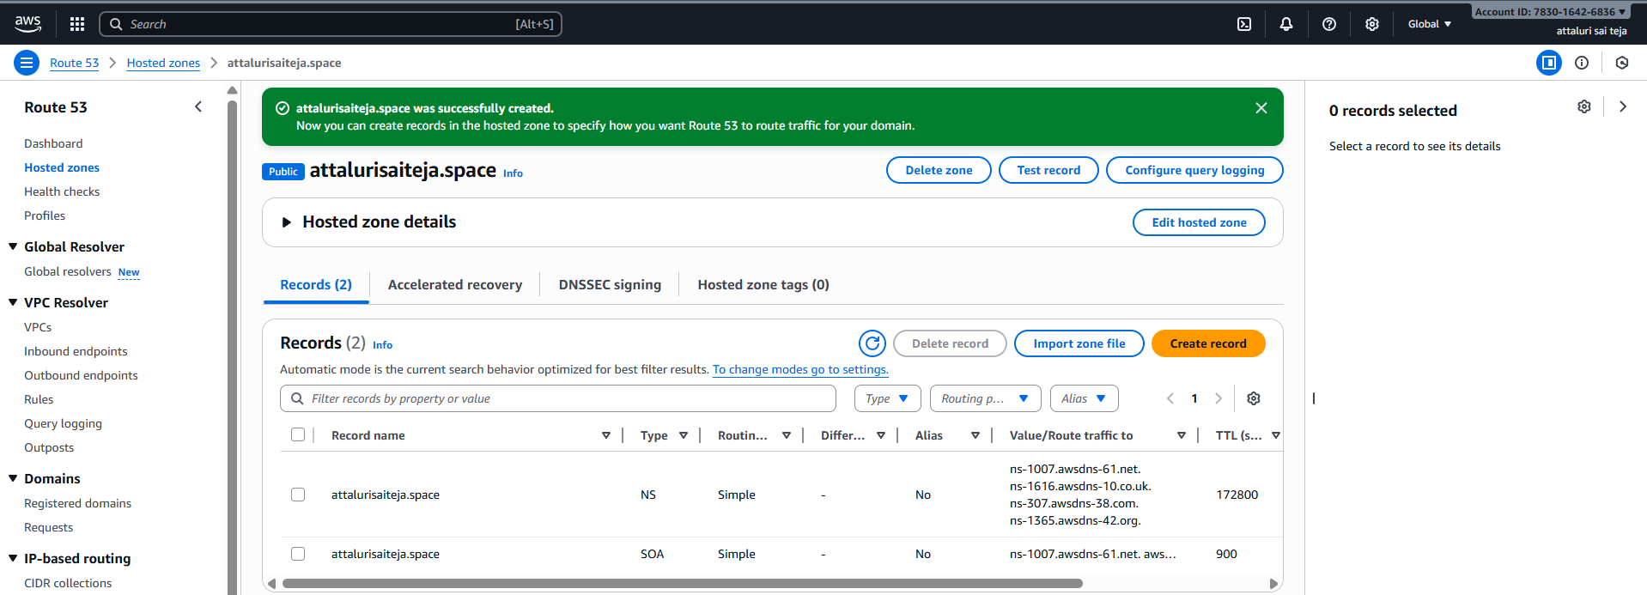
Step 4: Copy the Value/route server names from above picture and paste it in your domain vendor website
in name server section
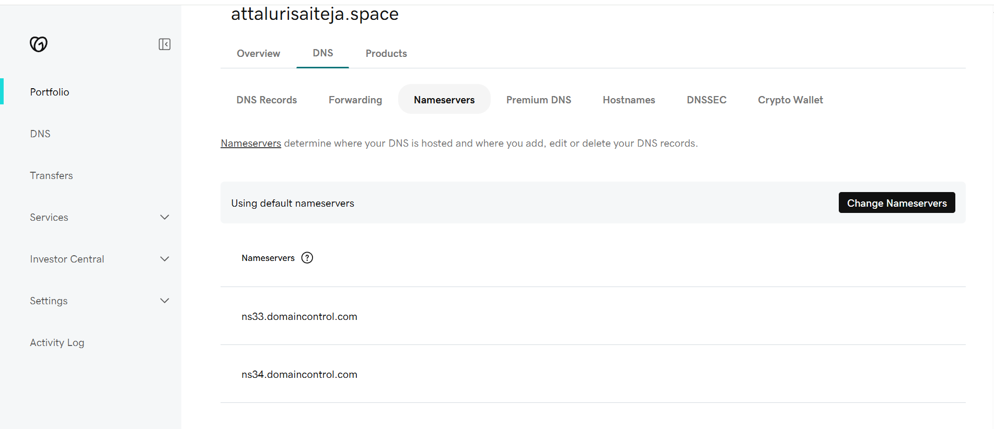

Step5: remove the old names add boxes accordingly
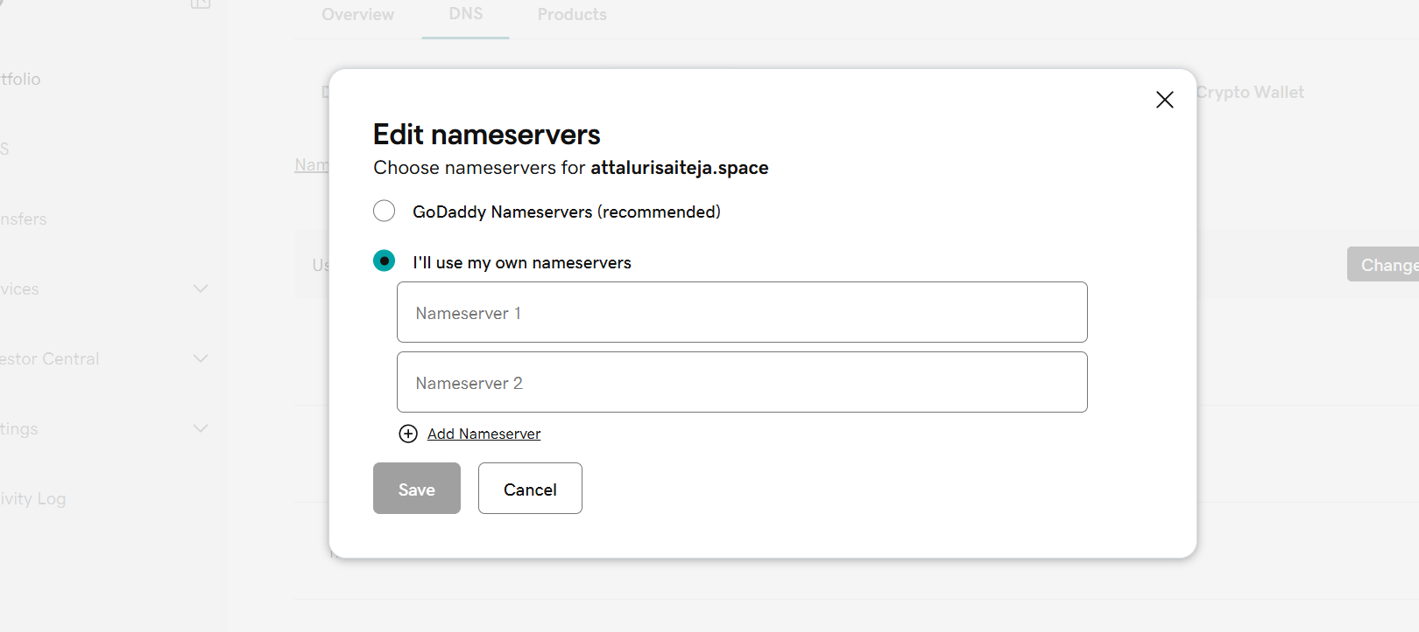
Step 6: Add the names and remove the dot at end
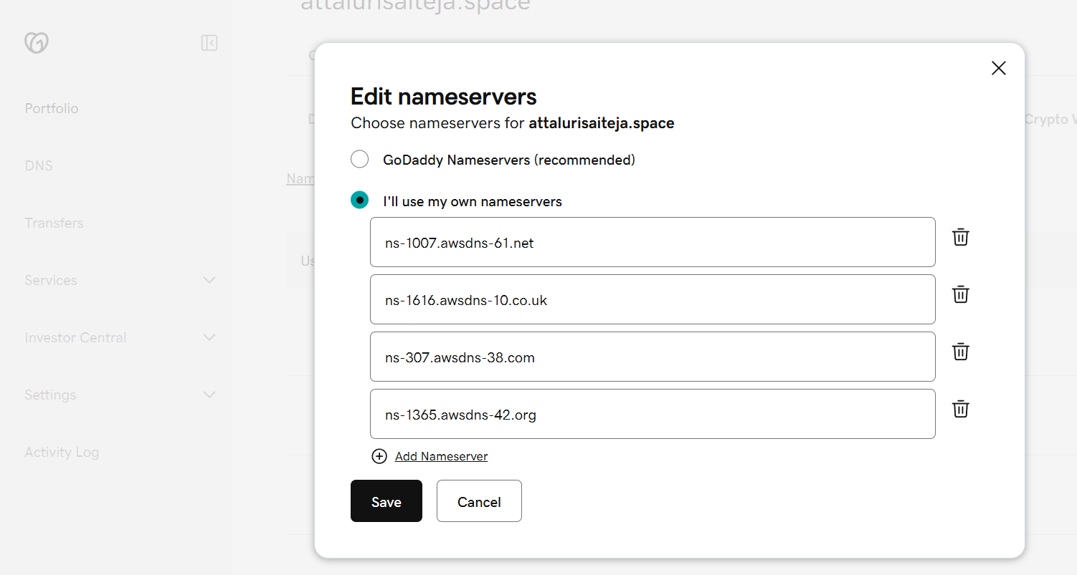

Step7: Navigate top cloud fron t and provide details
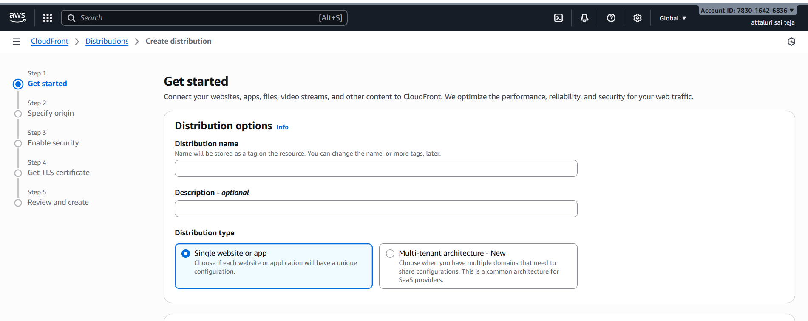
Step 8: Provide the names as your domain name and click on next
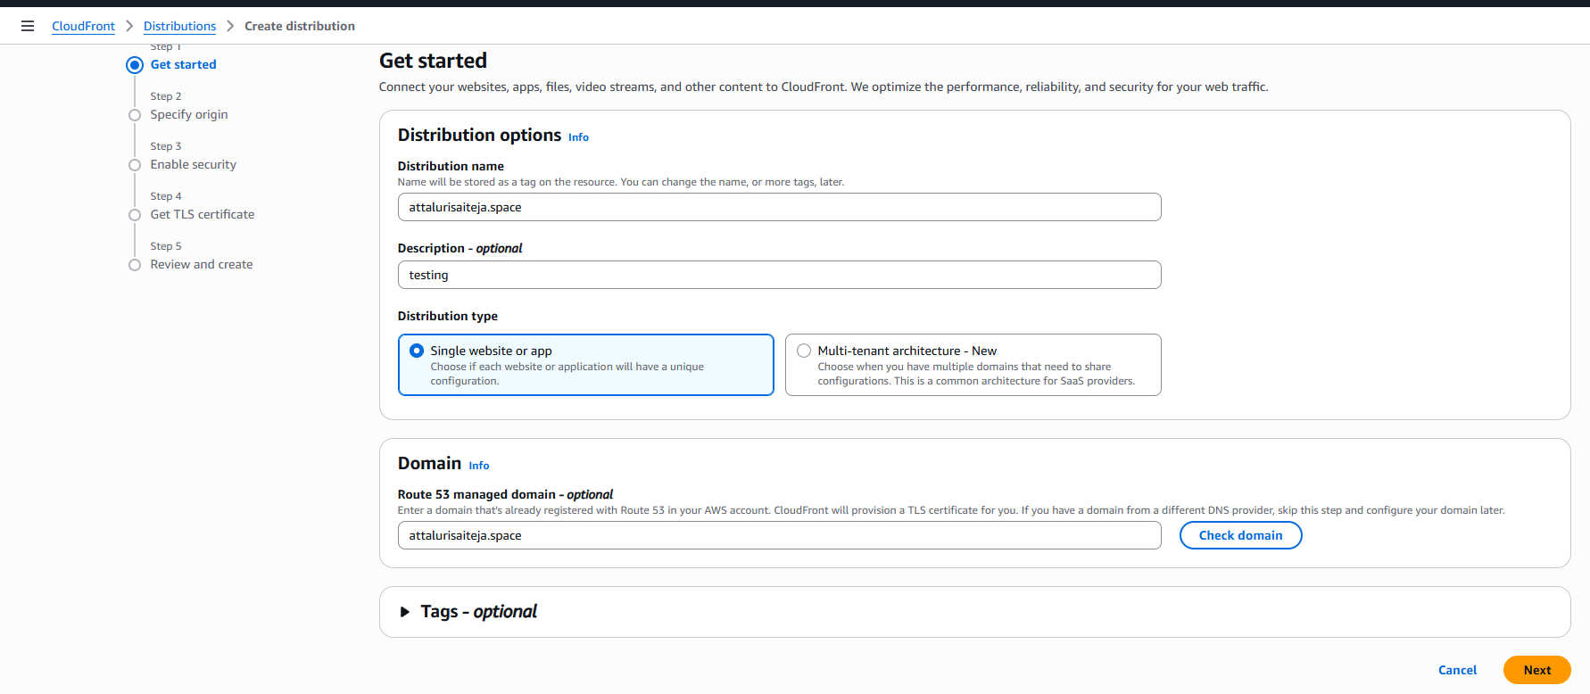
Step 9: Select the origin accordingly and select the s3 bucket
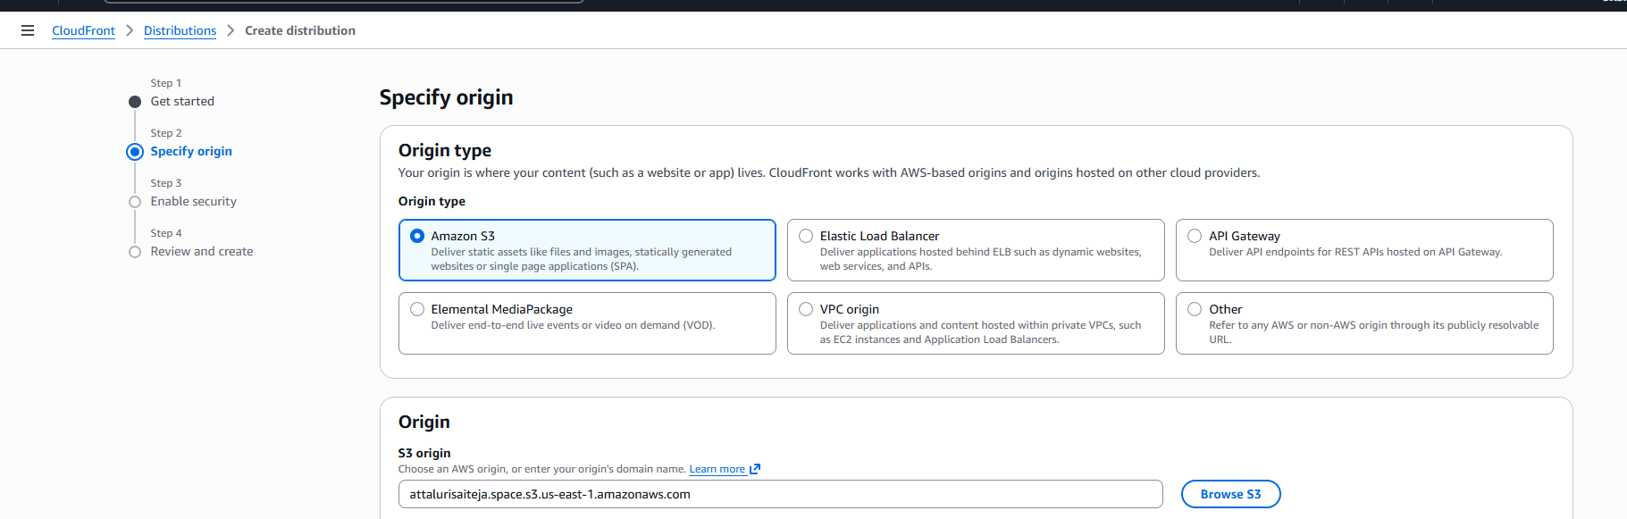

Step 10: Click on next
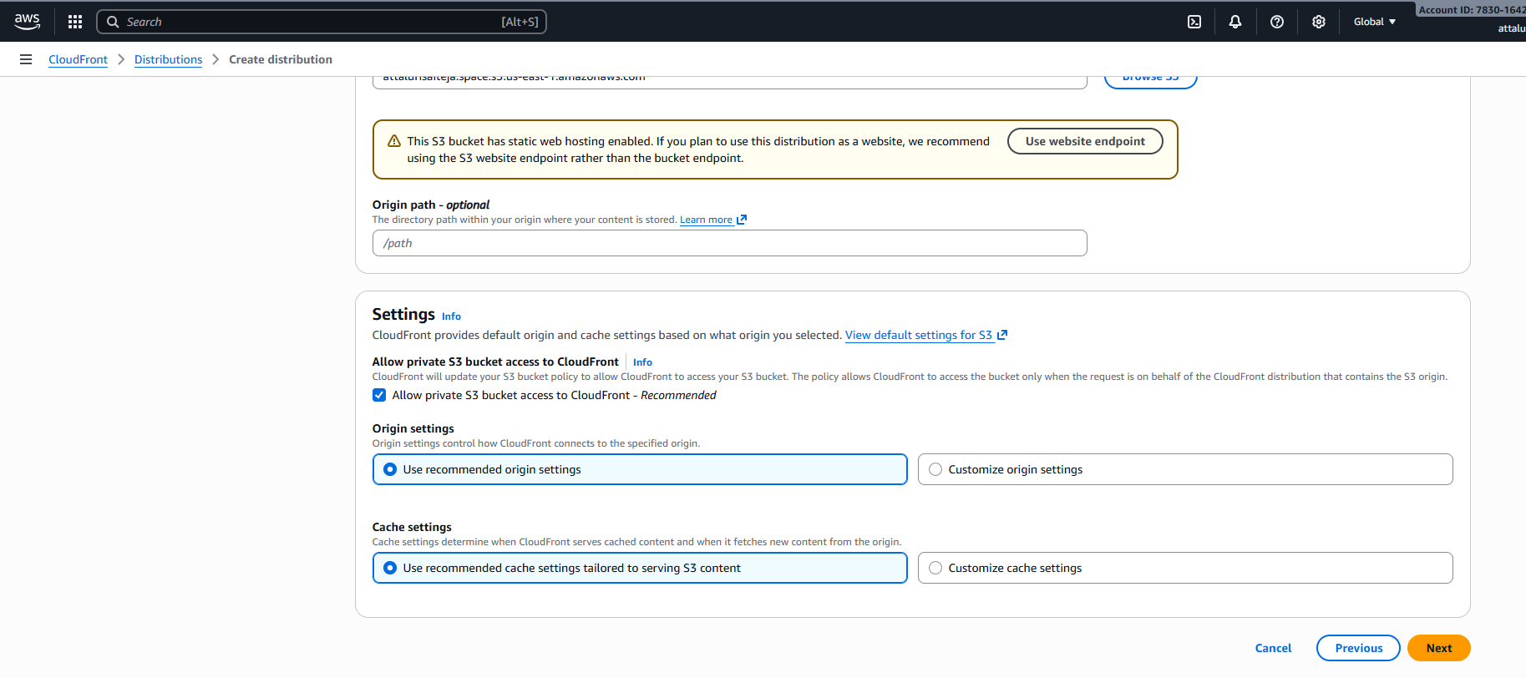

Step 11: select the security as unable
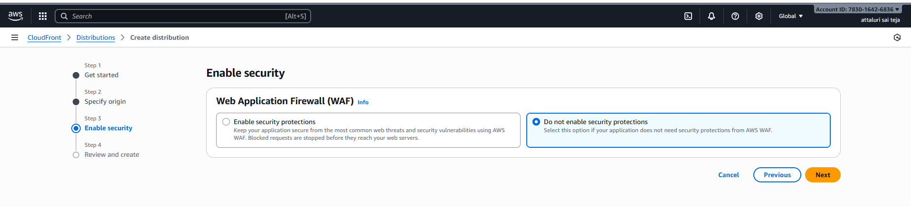
Step 12: Create a TLS certificate in manual or aws managed form
** aws will create faster then manual click on create certificate to create
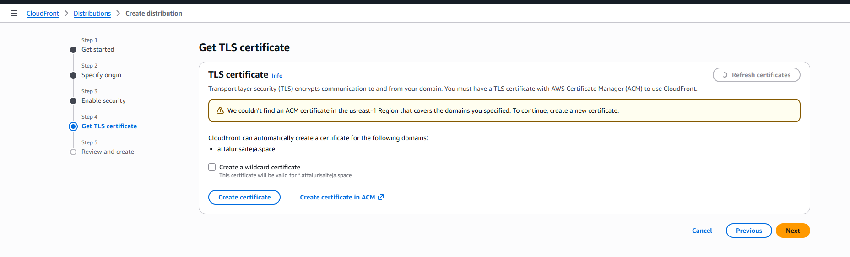

Step13: After getting the certificate click on next
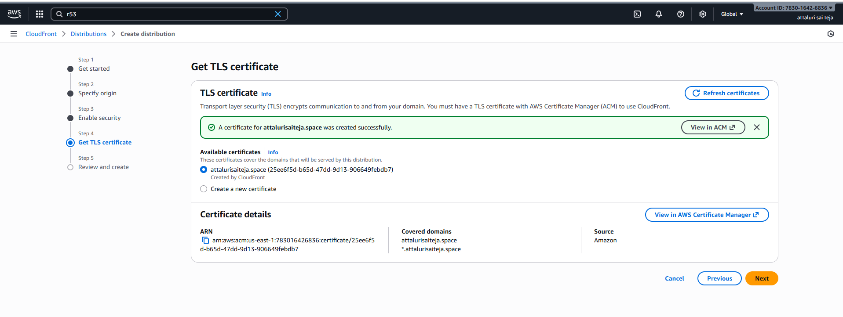
Step 14: Review the details and continue
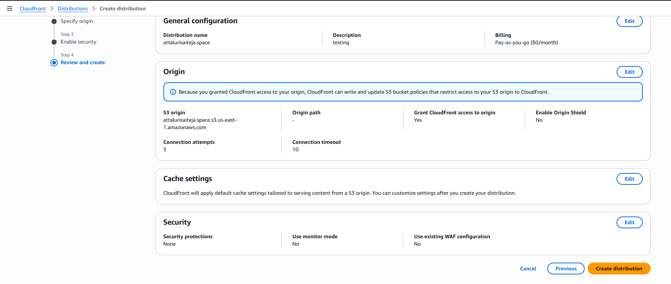

Step 15: got the error while creating and communicated with aws support and no use later created another account then service has been supported
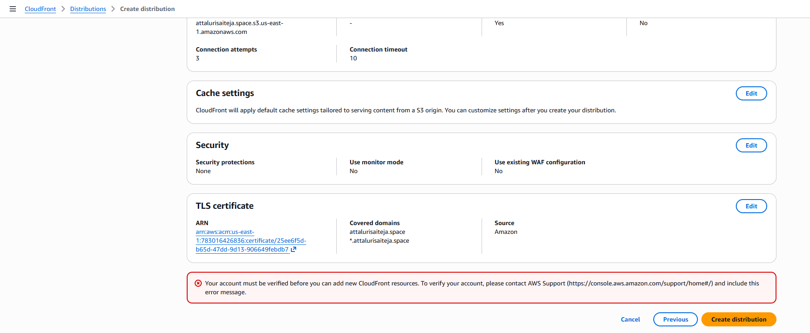
Step 16: Successfully created the distribution in new account
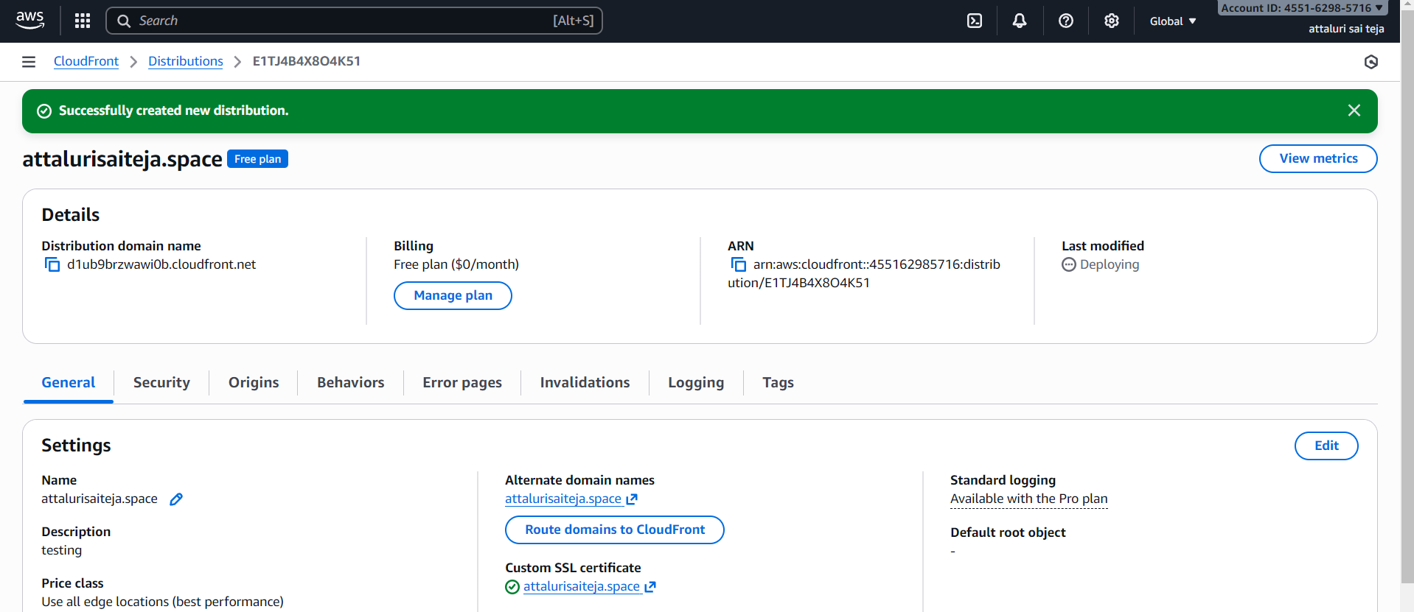
Step 17: Setup DNS routing automatically aws will managed it
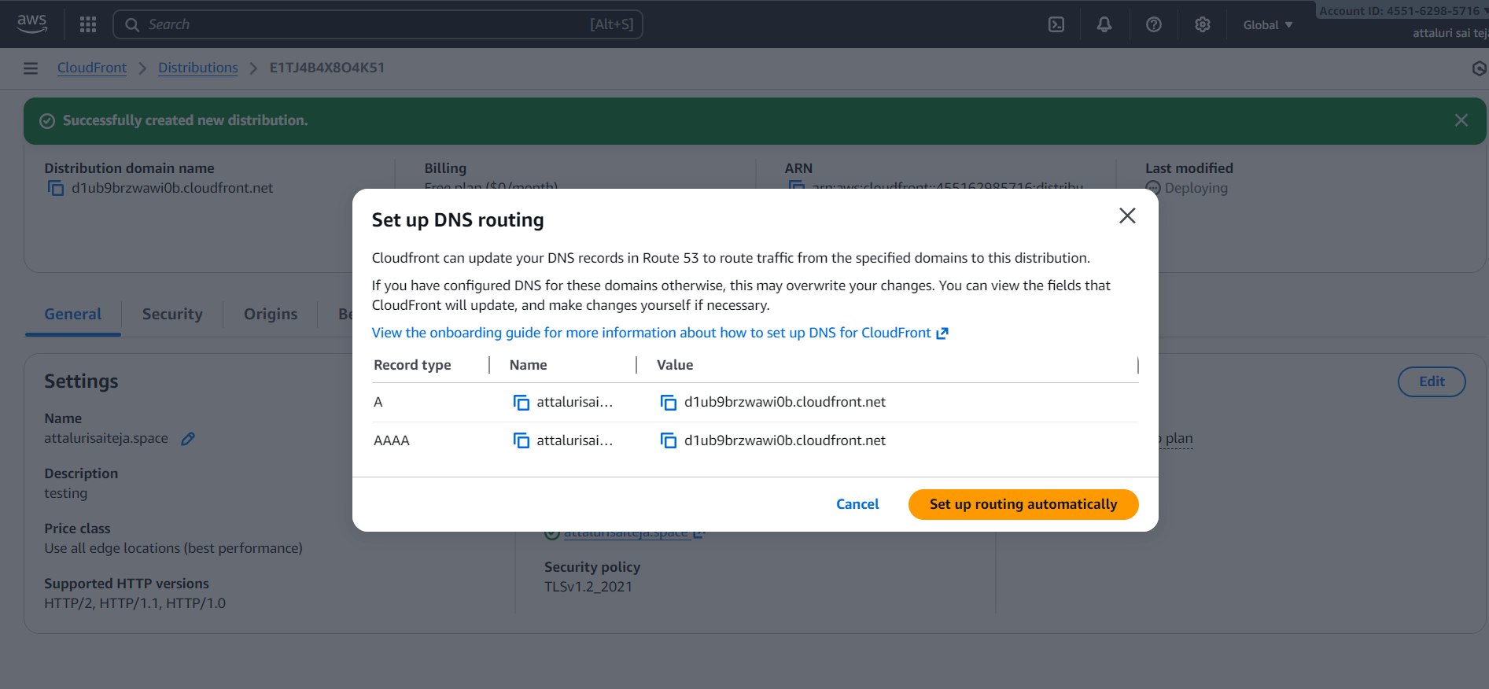
Step 18 : Checked the website with my domain name and it gets permission denied
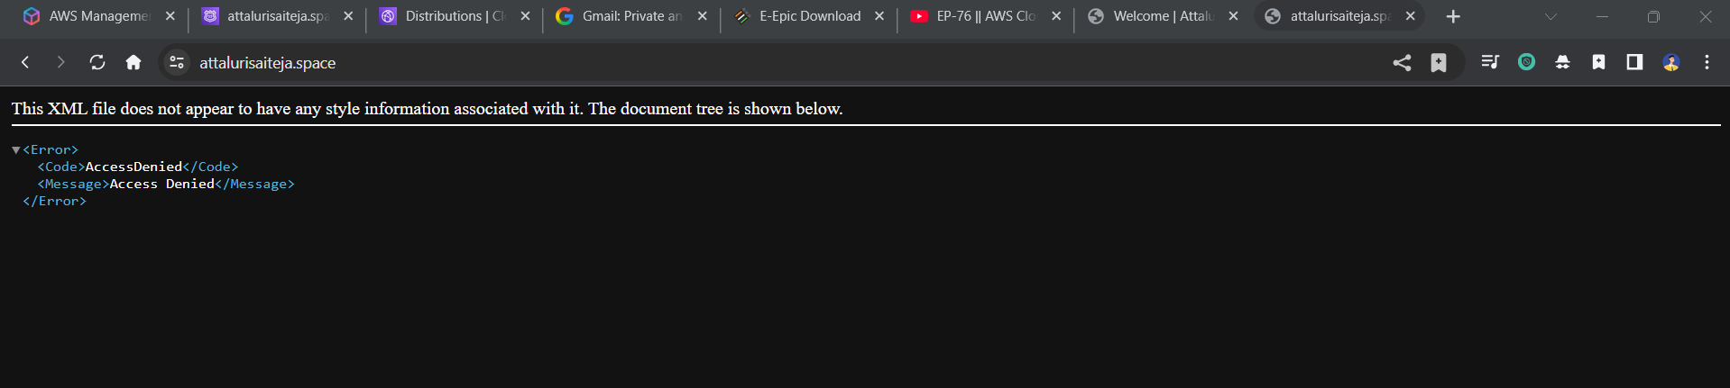

Step 19: Naviagte to Cloud front and select Invalidations tab
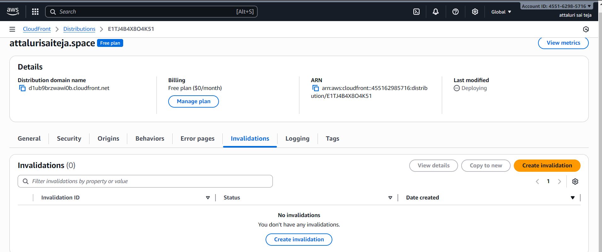
Step 20: Create invalidation by adding /index.html
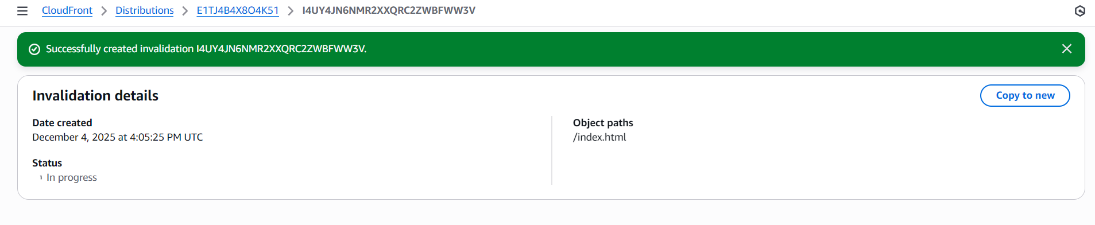

Step 21: create another by adding /*
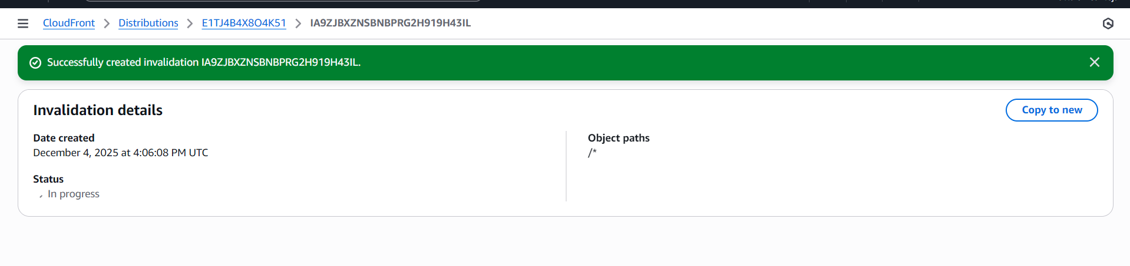
Step 22 : Navigate to origin and select edit origin and select accordingly
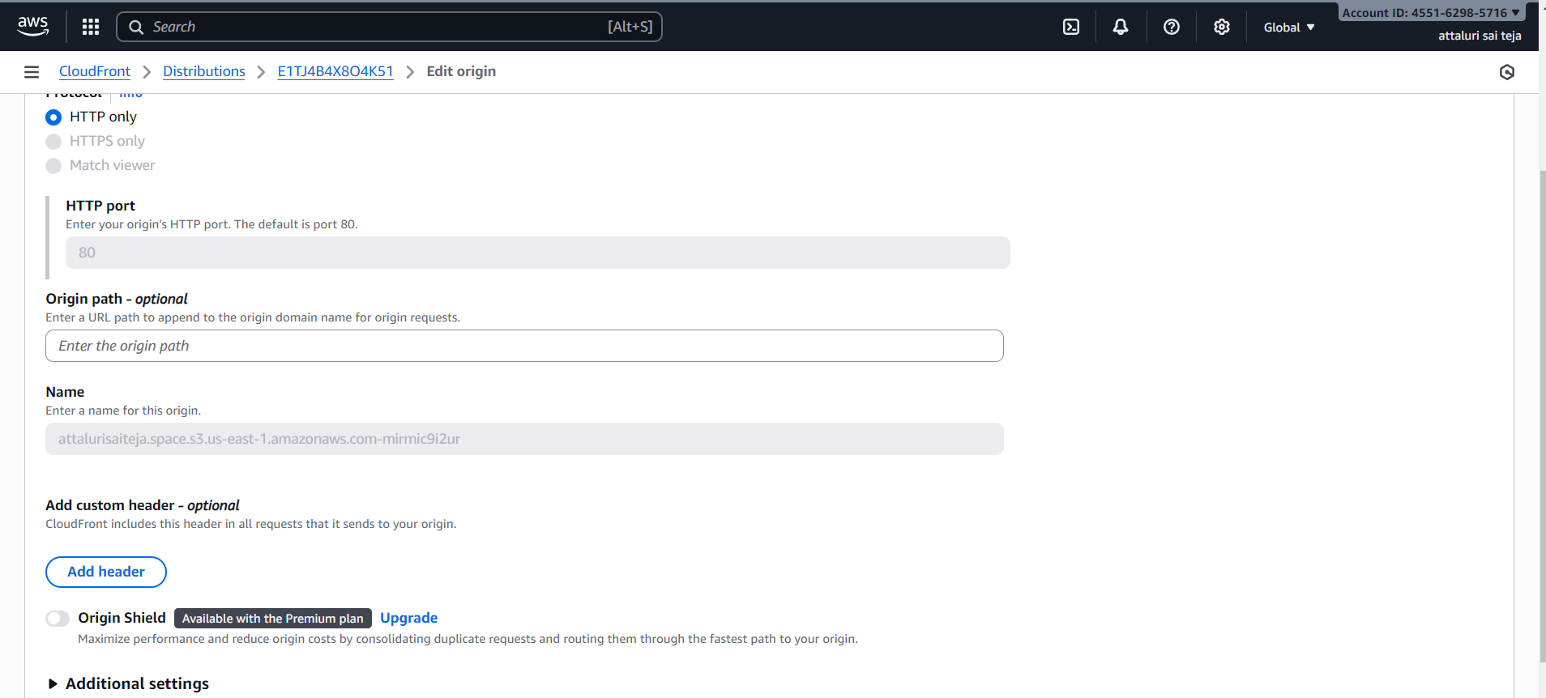
**NOTE**
Step 23 :navigate to S3 bucket and select the object and make it public once again
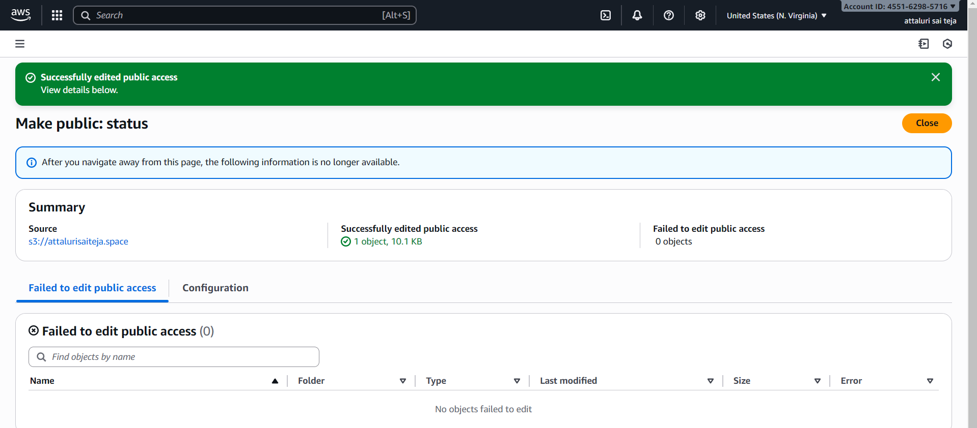
Step 24: Verify the website using domain name
